Camera Calibration Mathematical Basis

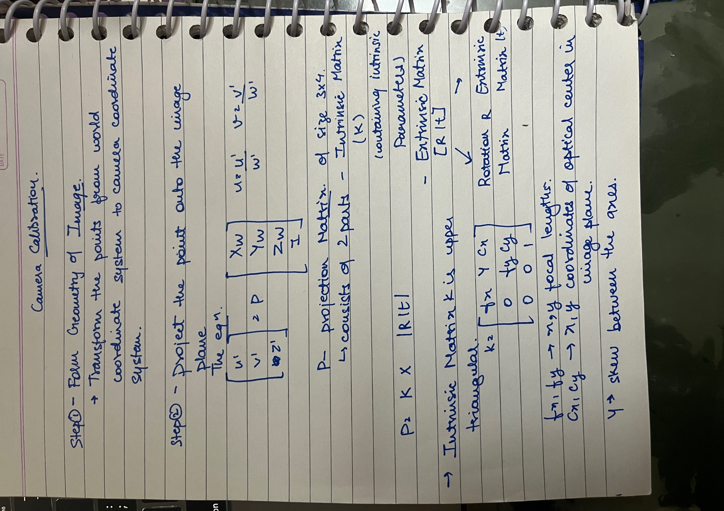

The camera calibration process refers to determining the intrinsic camera matrix and the parameters for the distortion models.